Caleb Hayden

CIS 310-01

Assignment 7

Due 10/23/17

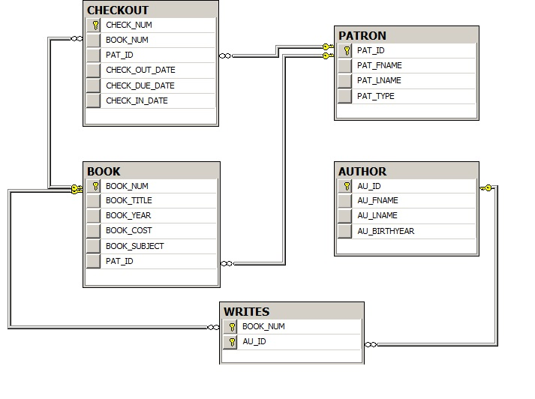

--65

SELECT BOOK_TITLE, BOOK_COST, BOOK_YEAR

FROM BOOK

--66

SELECT PAT_FNAME, PAT_LNAME

FROM PATRON

--67

SELECT CHECK_NUM, CHECK_OUT_DATE, CHECK_DUE_DATE

FROM CHECKOUT

WHERE CHECK_DUE_DATE IS NOT NULL

--68

SELECT BOOK_NUM, BOOK_TITLE, BOOK_YEAR

FROM BOOK

--69

SELECT DISTINCT BOOK_YEAR

FROM BOOK

--70

SELECT DISTINCT BOOK_SUBJECT

FROM BOOK

--71

SELECT BOOK_NUM, BOOK_TITLE, BOOK_COST AS [Replacement Cost]

FROM BOOK

--72

SELECT CHECK_NUM, BOOK_NUM, PAT_ID, CHECK_OUT_DATE, CHECK_DUE_DATE

FROM CHECKOUT

ORDER BY CHECK_OUT_DATE DESC

--73

SELECT BOOK_TITLE, BOOK_YEAR, BOOK_SUBJECT

FROM BOOK

ORDER BY BOOK_SUBJECT, BOOK_YEAR DESC, BOOK_TITLE

--74

SELECT BOOK_NUM, BOOK_TITLE, BOOK_YEAR

FROM BOOK

WHERE BOOK_YEAR = 2012

--75

SELECT BOOK_NUM, BOOK_TITLE, BOOK_YEAR

FROM BOOK

WHERE BOOK_SUBJECT = 'Database'

--76

SELECT CHECK_NUM, BOOK_NUM, CHECK_OUT_DATE

FROM CHECKOUT

WHERE CHECK_OUT_DATE < '4/5/2015'

--77

SELECT BOOK_NUM, BOOK_TITLE, BOOK_YEAR

FROM BOOK

WHERE BOOK_YEAR > 2013

AND BOOK_SUBJECT = 'Programming'

--78

SELECT BOOK_NUM, BOOK_TITLE, BOOK_YEAR, BOOK_SUBJECT, BOOK_COST

FROM BOOK

WHERE BOOK_SUBJECT IN('Middleware','Cloud')

AND BOOK_COST >70

--79

SELECT AU_ID, AU_FNAME, AU_LNAME, AU_BIRTHYEAR

FROM AUTHOR

WHERE AU_BIRTHYEAR like '198_'

--80

SELECT BOOK_NUM, BOOK_TITLE, BOOK_YEAR

FROM BOOK

WHERE BOOK_TITLE Like ('%database%')

--81

SELECT PAT_ID, PAT_FNAME, PAT_LNAME

FROM PATRON

WHERE PAT_TYPE like ('student')

--82

SELECT PAT_ID, PAT_FNAME, PAT_LNAME

FROM PATRON

WHERE PAT_LNAME like ('C%')

--83

SELECT AU_ID, AU_FNAME, AU_LNAME

FROM AUTHOR

WHERE AU_BIRTHYEAR IS NULL

--84

SELECT AU_ID, AU_FNAME, AU_LNAME

FROM AUTHOR

WHERE AU_BIRTHYEAR IS NOT NULL

--85

SELECT CHECK_NUM, BOOK_NUM, PAT_ID, CHECK_OUT_DATE, CHECK_DUE_DATE

FROM CHECKOUT

WHERE CHECK_IN_DATE IS NULL

--86

SELECT AU_ID , AU_FNAME, AU_LNAME, AU_BIRTHYEAR

FROM AUTHOR

ORDER BY AU_BIRTHYEAR DESC, AU_LNAME

--87

SELECT (COUNT(BOOK_NUM)) AS [Number of Books]

FROM BOOK

--88

SELECT (COUNT( DISTINCT BOOK_SUBJECT)) AS [Number of Subjects]

FROM BOOK

--89

SELECT COUNT(*) AS [Available Books]

FROM BOOK

WHERE PAT_ID IS NULL

--90

SELECT MAX(BOOK_COST)

FROM BOOK

--91

SELECT MIN(BOOK_COST)

FROM BOOK

--92

SELECT (COUNT(DISTINCT PAT_ID)) AS [Different Patrons]

FROM CHECKOUT

--93

SELECT BOOK_SUBJECT, COUNT (BOOK_SUBJECT) AS [Books in Subject]

FROM BOOK

GROUP BY BOOK_SUBJECT

ORDER BY [Books in Subject] DESC, BOOK_SUBJECT

--94

SELECT AU_ID, COUNT (AU_ID) AS [Books Written]

FROM WRITES

GROUP BY AU_ID

ORDER BY [Books Written] DESC, AU_ID

--95

SELECT SUM(BOOK_COST) AS [Library Value]

FROM BOOK